**Without Gini**

**Start values**

start = c(a = 5000, b = 0.01, alpha = 1, beta = 0.001),

Excluded countries – UAE, Luxembourg

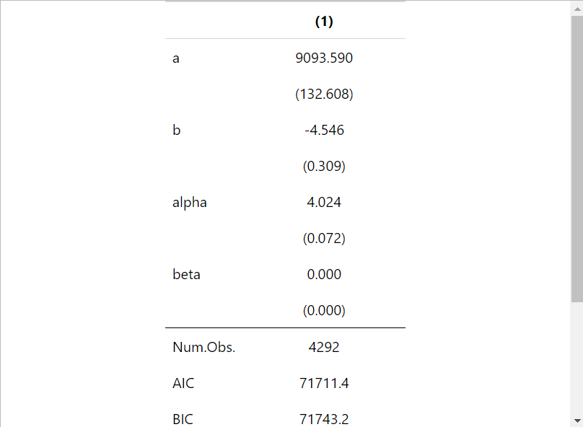

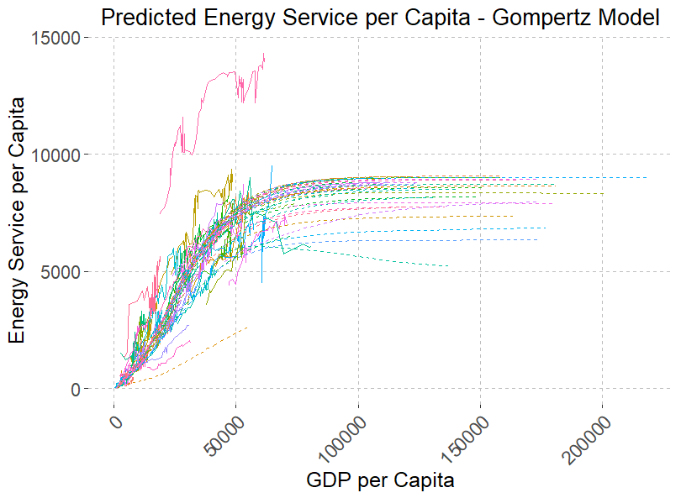

**Model 2: with Gini – case1**

**Start values**

start = c(a = 5000, b = 0.01, alpha = 1, beta = 0.001),

Excluded countries – UAE, Luxembourg

